Name Surname :
Student Number :
Group Number :

1) a) Classify the soil, for which the grain size distribution and consistency limits are given below, according to Unified Soil Classification System (USCS) and American Association of State Highway and Transportation Officials (AASHTO) Classification System.
No 4  Passing (%) | No 10  Passing (%) | No 40  Passing (%) | No 200 Passing (%) | w_{L}  (%) | w_{P}  (%) | Cu | Cc
48 | 45 | 28 | 15 | 27 | 17 | 8 | 4
- Explain the meaning of the terms given below.
    - Poor graded soil
    - ML, OH, GM, SP
    - Capillarity
    - Relative consistency
    - Over consolidation Ratio
- An excavation will be opened in the soil profile shown in the below figure. The permeable soil layer underlying the clay was observed to be under the artesian pressure. If the water in the drill hole rose to a height of 7 m above the permeable layer,
  - How deep (H) can the excavation proceed before the bottom heaves?
  - Compute the factor of safety against heaving if the excavation reaches a depth of H=10 m.
  - Compute the elevation head, pressure head and total head at the point of A by considering the top of sand layer as reference level.
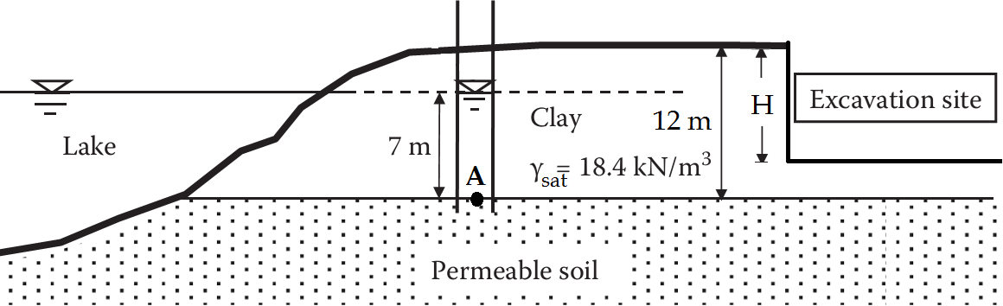

- The results of consolidated- undrained (CU) performed clay soil samples are given in the below table:
Test | Cell Pressure, σ₃  (kPa) | Deviator Stress, (σ₁− σ₃)_{f}  (kPa) | Pore Pressure, u_{f}  (kPa)
1 | 200 | 247.7 | 45
2 | 400 | 426.7 | 105.5

a) Compute the drained and total shear strength parameters of the clay soil.
b) Determine whether the soil is normally consolidated or overconsolidated clay according to the results obtained from the CU test.
c) Compute the angle that the failure plane makes with respect to horizontal.

4) A building which has 12 m x 15 m mat foundation will be constructed on a soil with the given profile as shown below. The consolidation test results on the samples from the clay layers are also given.
a) Calculate the vertical stress increase in the middle of the clay layer under the center of the tank due to constructed building (by using 2:1 Method).
b) Compute the primary consolidation settlement that will take place underneath the center of the foundation.
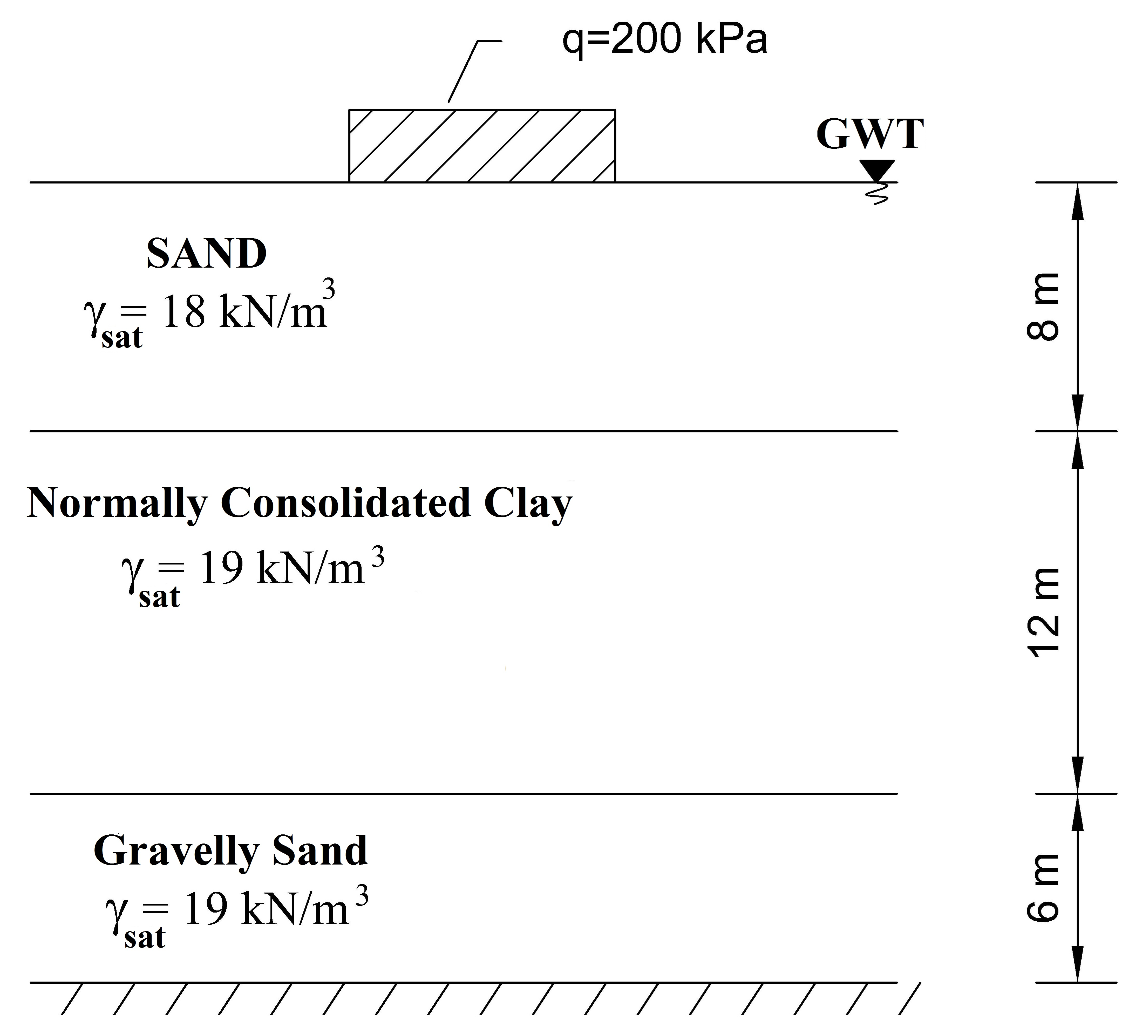
Stress (kPa) | Void Ratio
0 | 1.18
25 | 1.17
50 | 1.16
100 | 1.12
200 | 1.05
400 | 0.98
800 | 0.91
400 | 0.92
200 | 0.93

5) a) What are the factors that affect compaction?
b) The laboratory results of standard compaction test are shown in below.

Water content (%) | 14.0 | 16.0 | 18.0 | 20.0 | 22.0 | 24.0
Moist density (Mg/m³) | 1.903 | 1.960 | 2.006 | 2.016 | 2.025 | 2.008

        - Plot the compaction curve and determine the compaction parameters (maximum dry density and optimum moisture content of the soil).
        - For the soil in borrow area, water content, natural density, and specific gravity of soil is found to be 15%, 1.70 Mg/m³, and 2.70, respectively. Calculate how much filler material is necessary for compacted fill of 100000 m³ that meets 95% relative compaction.
Time is 90 minutes. Good luck…

